**Research Findings**

The pandemic has changed 2020 unexpectedly and dramatically. The pandemic has impacted people’s life in all aspects, and its influence on the economy is more than anyone has ever expected. This project is designed to take a look at how economy by examining the unemployment rate at the period of pre-pandemic and during pandemic. It first studies the unemployment rate changes over time, looking at separate trends pre-pandemic, during the first wave and the second wave. Second, it breaks the unemployment rate into male and female to see which group receives more impact. Third, it examines unemployment rate by race. Last but not least, it studies other economic or financial index like S&P500, personal savings, and job openings that relates to unemployment rate to offer a broader view of examining the economy.

From the interactive plot of “unemployment rate” (see figure 1), we can see that the difference between pre-corona period, first wave, and second wave. Even though experts may suggest that we are still in the first wave, I classify July to September as second wave because there is a relatively obvious change in unemployment rate and other economic indicators. Even though from September 2019 to February 2020, there seems to be turbulences in the unemployment rate, in fact, the unemployment rate remains low as the highest point is 3.6. The rate for the first wave looks much worse than the pre-period, as it spikes to more than 14% during the first months. This might be due to the closing of restaurants, stores and bars, many small businesses have experienced great hardship during the first wave, which shouts for reopening and back to business. As for the second wave, it seems that there is a decline in unemployment, mostly because small business is back to life (almost) and companies are getting used to remote working. However, the unemployment rate is still very high, with a lowest point of about 8%.

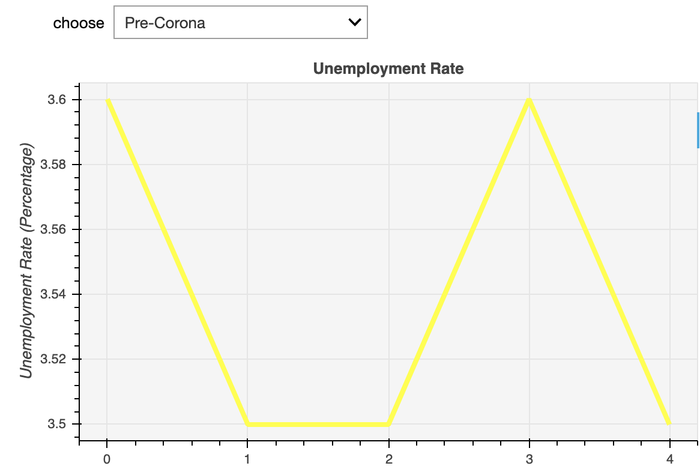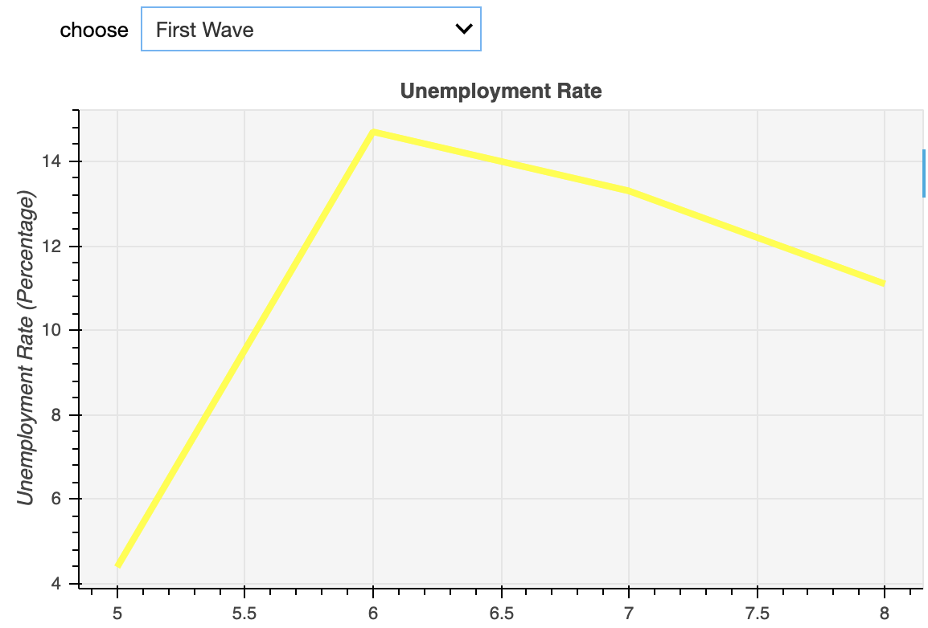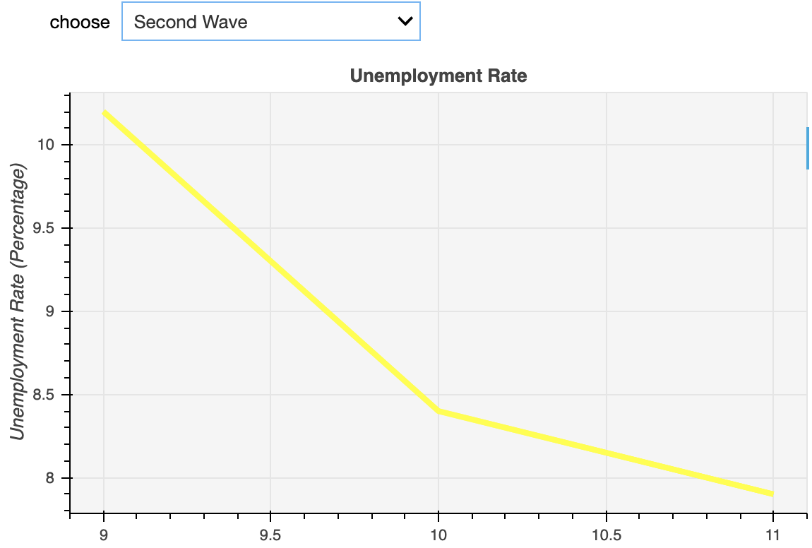

Figure 1

The difference between male and female workers on the unemployment issue can be seen on the graph “unemployment rate by gender” (see figure 2). We can conclude from the graph that women have experienced more impact than men during pandemic. Compared with before pandemic, which suggests that unemployment rates are at the same level for both genders, the during-pandemic shows a large difference between men and women in private sector employment. This can partly prove the point that pandemic is the major contributor to the difference.

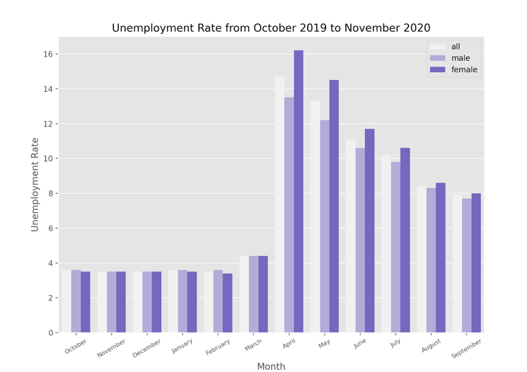

Figure 2

As for racial difference in unemployment rate changes (see figure 3), Hispanic people experience the biggest difficulty in securing a job, but the unemployment level also drops dramatically for them. Starting from the beginning of second wave, we can see that white people returns to a relatively low unemployment level most quickly, while for Asian Americans, even though they have the lowest point of unemployment previous to the pandemic, the speed for recovery is not the fastest.

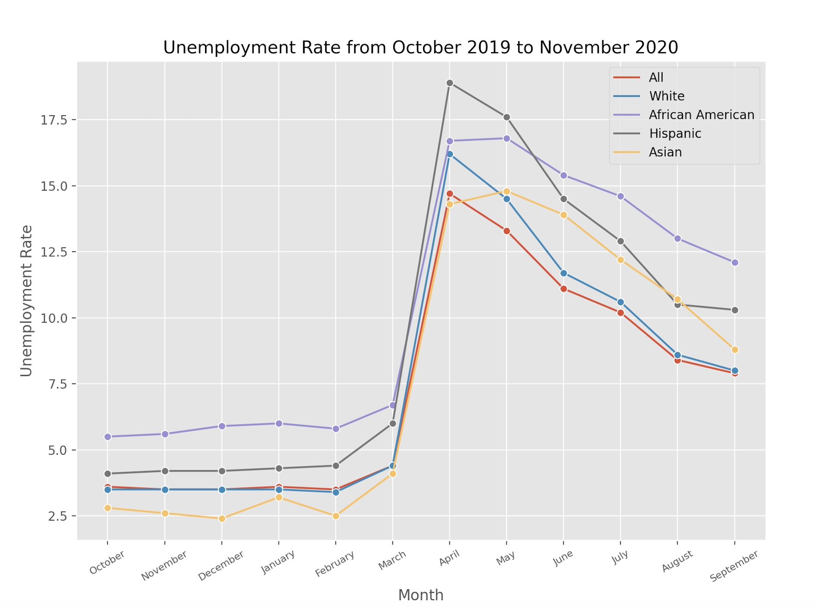

Figure 3

As is shown in figure 4, the number of job openings is an economic indicator that provide information about the labor market, and it has a strong negative relationship with unemployment rate. The lowest point for job openings is the peak for unemployment, and it starts to rise back which means that more jobs are starting to open in the job market, which might be a piece of good news for graduate students who are looking for a job. Unemployment rate has positive relationship with personal savings, which might be due to people’s crisis awareness and risk aversion that we may want to save just in case. It might also because spending is more associated with economic prosperity, while saving suggests the opposite. The S&P 500 index shows a small inconsistency with unemployment rate trend, as its largest decline is slightly ahead of the peak of unemployment. One possible explanation is that since people have started to predict an economic crisis, investors have made their moves, and stock and bond prices have dropped before the other economic events start to manifest the downward trend. Now the index starts to go back and even suggests a trend better than before pandemic. Whether this is because people are too optimistic about the reality or because people are large-sum purchasing for future preparation still needs further investigation.

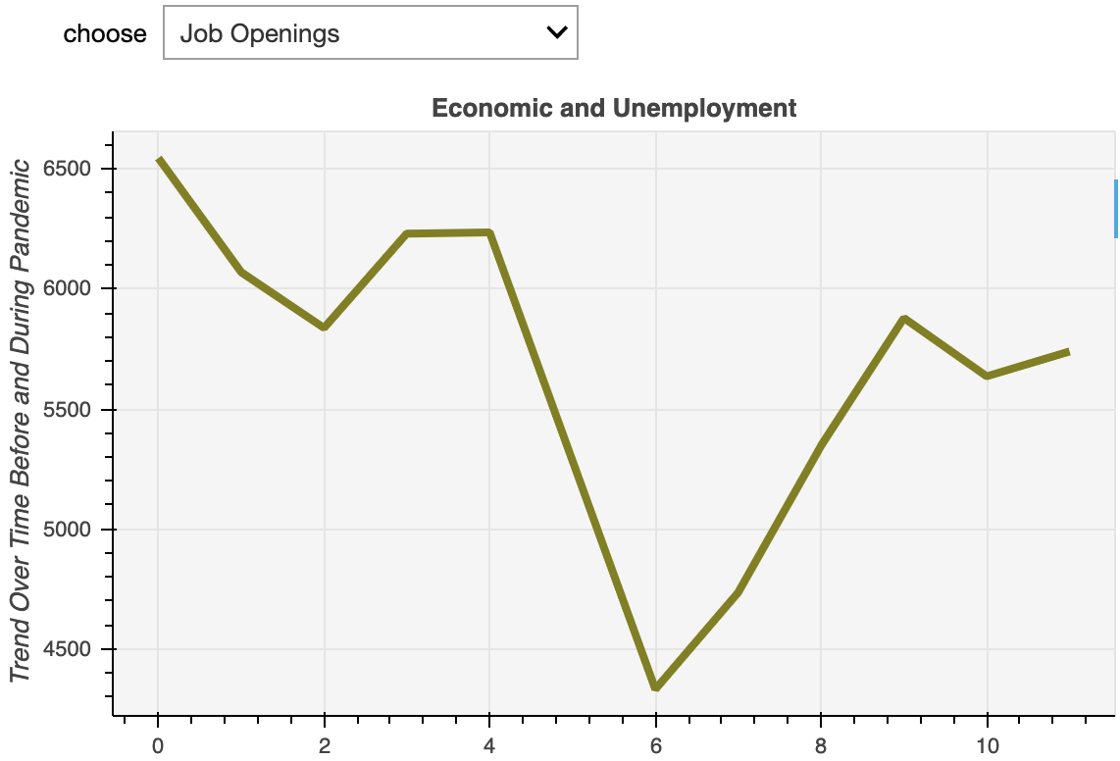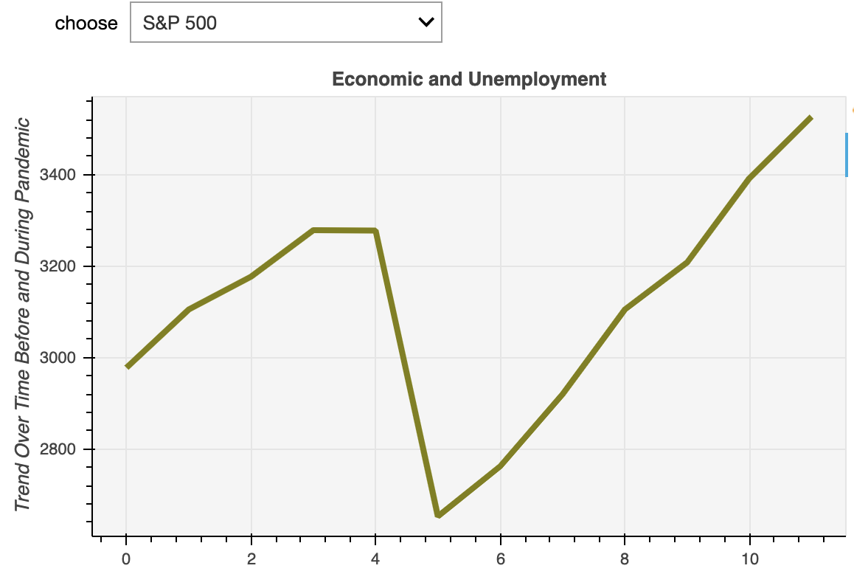

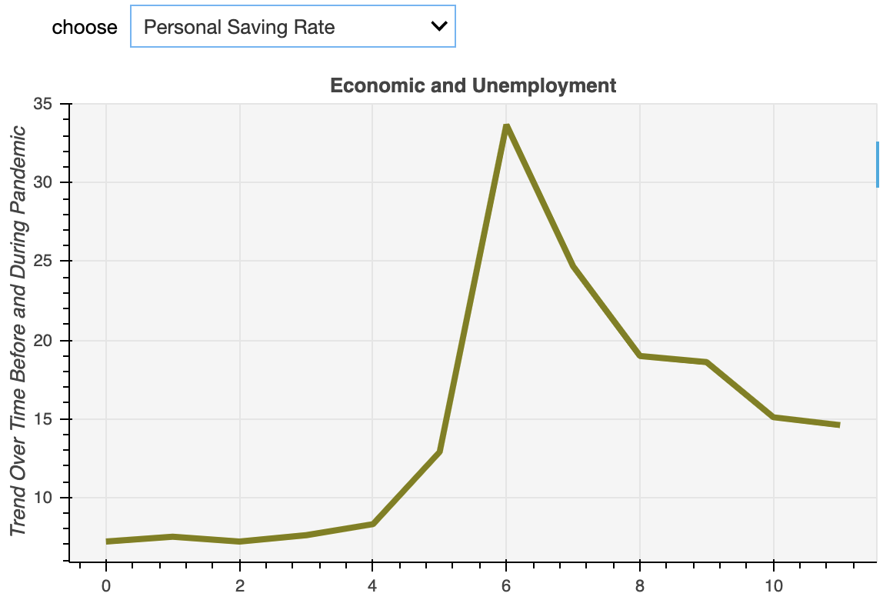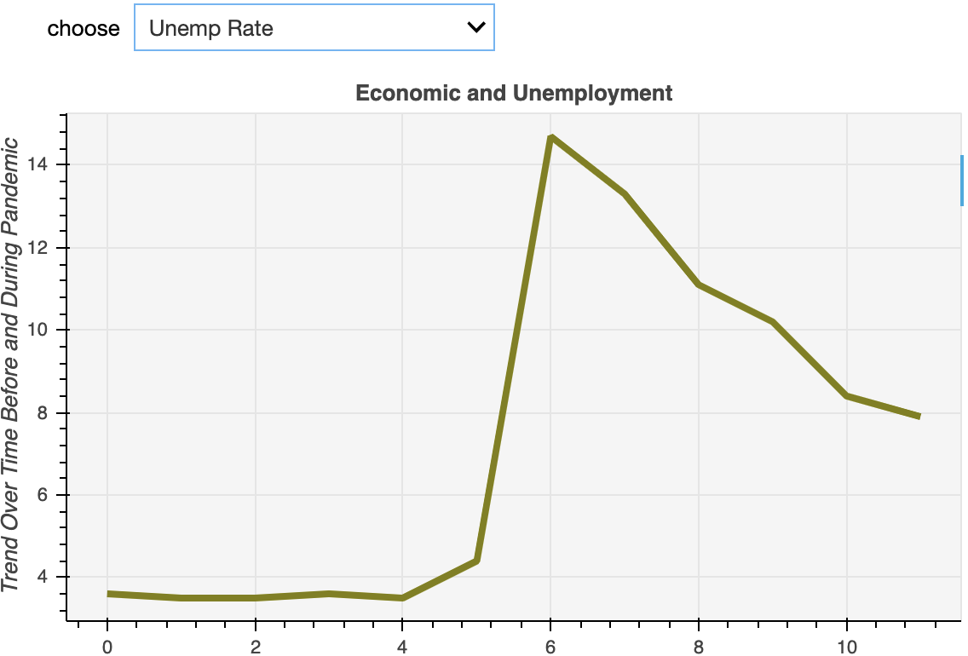

Figure 4

In conclusion, we can see that this pandemic affects women’s career more than men, and the minority suffers the most in the job market. Even though some economic indicators might suggest that the worst part of the pandemic has already passed, but the unemployment rate is still high and we cannot predict how long the high rate is going to last.